

**CAT I Lab**

**Course Name: Internet & Web Programming Duration: 60mins**

**Course Code: CSE3002**  **Max. Marks: 15**

Think that you are the owner of a company named 'XYZ'. Your company has an opening Pizza Shop 2.0. Make an advertisement using HTML and CSS. Make the website more attractive with following layout.

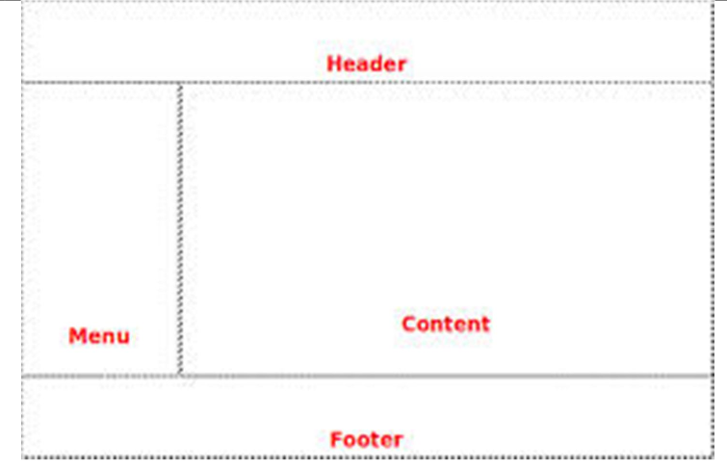

**Provide a navigation to access the following form**

